Trichetra isabella. Illustration 27 Insects 10.
Alis anticis albis, fasciis tribus apiceque nigris, maculis subocellatis duobus inter fasciam secundam tertiamque, maculis octo apicalibus; posticis nigris, basi anguste, apiceque marginali ochraceis. (10 figures 1 and 3)
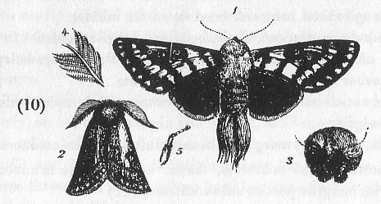
27. INSECTS 10. Trichetra isabella male.
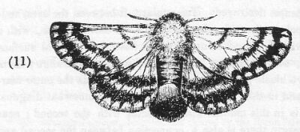
28. INSECTS 11. Trichetra isabella female.
Antennae destroyed. Triangular tuft between the eyes, reddish ochre, the sides brown; hairs on thorax white, with a yellowish tinge. The upper wings have their general surface white, the margin at the base being ochrey-orange; there are two black parallel bands suffused towards the outer margin, and in this way connected; a third somewhat diagonal band is in this manner also connected with the second; near the margin there is also a connection between the second and third bands by means of a brownish band interspersed with white scales, and in this are two subocellated spots, white, with an ochrey-orange roundish pupil; the second just in front of the third band white in front, and ochrey-orange behind; behind the third black band there comes a narrow band of white scales, with an ochrey-orange spot at the end near the outer margin. The tip of the wing is (broadly) velvety brown, with eight marginal whitish spots; the fringe is mixed with black and ochrey; the ochrey tingeing the posterior margin of some of the outer spots.
The under wings are velvety brown; the base being obscurely ochrey; the yellowish colour running up into brown; the fringe behind is ochrey.
The under wings are ochrey at the base; the outer margin of the first pair being dark brown; the brown of the second pair is scolloped on the margin as is that of the first. The body above, on the sides and on the margin beneath, is covered with velvety black hair; beneath there is a somewhat indistinct longitudinal brownish band down the middle.
The hairs on the end of the body are longish, and not in a dense close effused tuft as in the female; the legs are hairy, the brushes being black and yellowish white.
Female: Alis anticis albis fasciis tribus brunneo-nigris apice brunneo-nigris.
Maculis 8 (saltem) marginalibus antice albis, postice ochraceis.
Alis posticis, basi ochraceis, fascia, apiceque late brunneo-nigris, margine postico subaurantiaco. Illustration 28 Insects 11.
Since the figure of this was drawn from one of the two rather injured specimens presented by Captain Grey, I have seen another specimen in finer condition, from which I shall take the more particular description of the bands on the upper wing.
The head and thorax are covered with long and close hairs; the tuft between the eyes being of a brownish ochrey colour; the sides blackish. The hairs on the fore-part of the thorax are ochrey-brownish, gradually passing into white on its general surface, which however has more or less of a yellowish tinge.
The upper wings are white and covered with longish loose scales. Near the base is a narrowish transverse dark brown band, with another considerably before the middle of the wing running parallel to it; behind the middle there is a third band, the inner extremity being at the same distance from the second band as the second is from the first; but it gradually slopes away towards the outer margin, and is thus nearly parallel to the posterior margin, which has also a brown band, scolloped behind, and with at least eight spots on the margin, which is of a brownish yellow, as in the outer margin.
The under-wings, from the base to the middle, and (narrowly) on the outer margin and behind, are brownish ochrey; the other half of the wing is blackish brown, scolloped behind; and having an indistinct ochrey band passing transverse through it, which ochrey band has some darker-coloured scales mixed with it.
The undersides of both wings differ but little from the upper sides; the upper pair more especially however have on the basal and submarginal parts longish ochrey coloured hairs instead of white scales.
The body above is, at the base, ochrey; the sides, and two or three other segments brownish black, darkest just in front of the large thick-set tuft of brownish orange hairs at the extremity; beneath, down the middle, is a band of brownish orange, the segments to the sides of this being black at the base and orange at the tip; the legs are varied with black and ochrey white.
This seems congeneric with the Arcturus sparshalli of Mr. Curtis, described in the 7th volume of the British Entomology, folio 336, as a British insect; but there seems doubt of the correctness of this. The name, having been pre-occupied in Natural History, has been changed by Mr. Westwood to Trichetra, in page 92 of the Generic Synopsis, appended to his Introduction to the modern Classification of Insects.

